1. **The ACTOR database has a table with the following attribute. The primary key are undefined.**

* **Emp(ACTno: int, name: string, dob: date, PhNo: int)**

**a) Create the above table.**

**b) Display table structure.**

**c) Enter five tuples in the table.**

**d) Display all the tuples in ACT table.**

**SQL Commands:**

Step 1: Create the table

CREATE TABLE EMP(

ACTno int PRIMARY KEY,

name VARCHAR(100),

dob date,

PhNo int

);

Step 2: Display the structure.

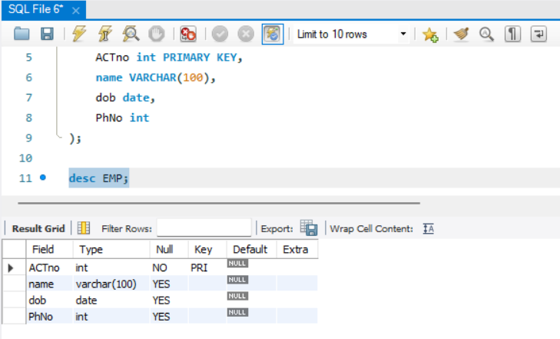desc EMP;

Step 3: Insert the data.

insert into EMP (ACTno, name, dob, PhNO) values (1,'John Doe','1990-01-01',12456776);

insert into EMP (ACTno, name, dob, PhNO) values (2,'Jane Smith','1995-05-10',1023892);

insert into EMP (ACTno, name, dob, PhNO) values (3,'Alice Jhonson','1998-03-05',983820202);

insert into EMP (ACTno, name, dob, PhNO) values (4,'Bob Williams','1996-10-01',82456776);

insert into EMP (ACTno, name, dob, PhNO) values (5,'John Doe','1992-05-10',929956776);

Step 4: Display the data in the table.

select * from emp;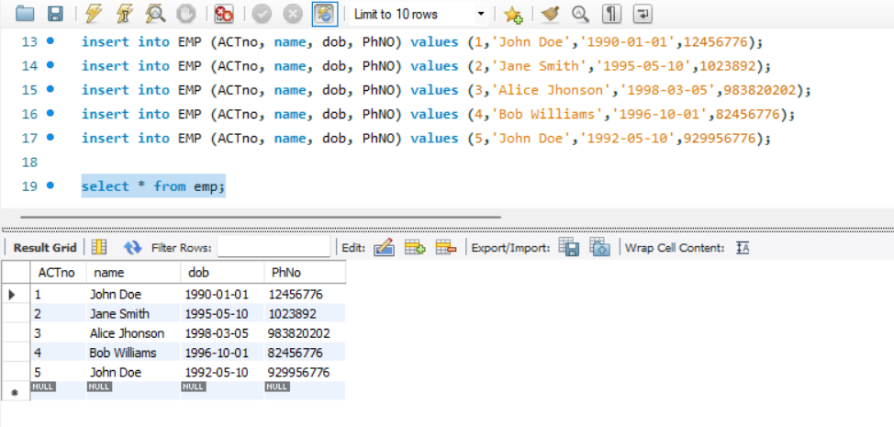

1. **Perform the following:**

* **Consider dept table: (deptno, dname, loc)**

**a) Altering a Table: - Adding/Dropping/Truncating Table.**

**b) Rename the table dept ad department.**

**c) Rename the column dname to dept_name in department table.**

**d) Change the data type of column loc to char with size 10.**

**e) Deleting table department.**

**SQL Commands:**

Step 1: Create and display the table.

create table dept(

deptno int primary key,

dname varchar(200),

loc varchar(100)

);

desc dept;

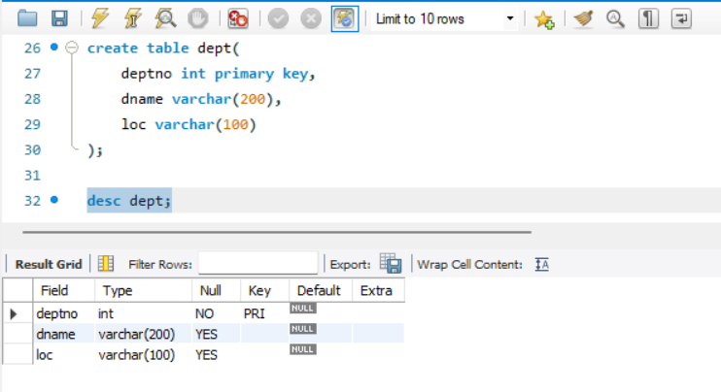

Step 2: Alter(rename) the data.

alter table dept rename to department;

desc department;

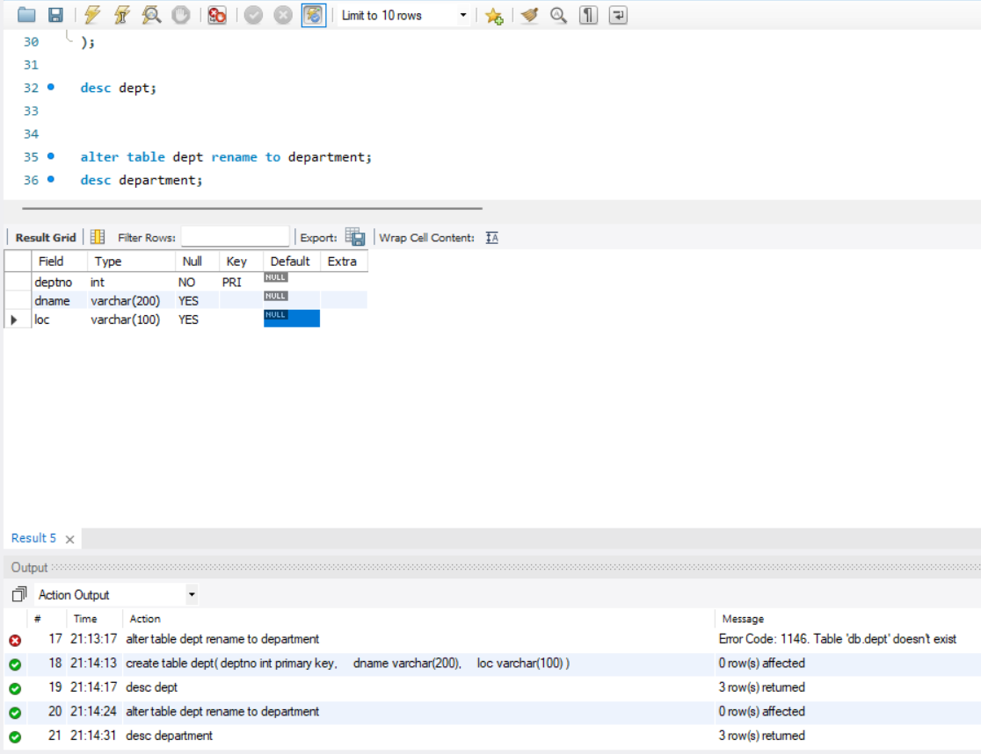

Step 3: Alter(rename) the data.

alter table department rename column dname to dept_name;

desc department;

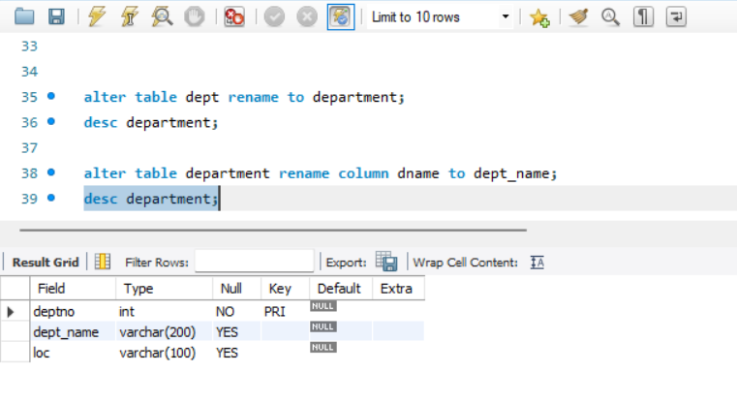

Step 4: Alter(modify) the data.

alter table department modify loc char(10);

desc department;

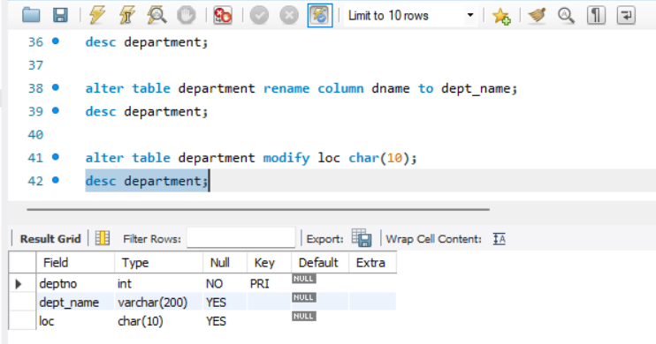

Step 5: Drop the data.

drop table department;

desc department;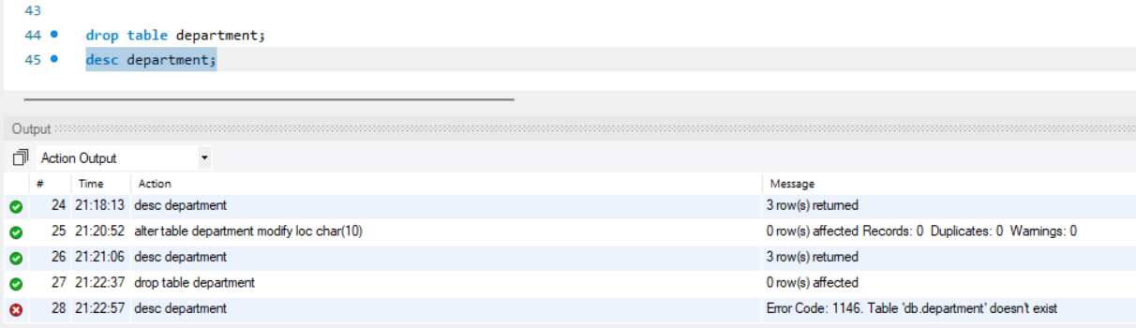

**3. Company database has a table with the following attributes.**

* **Company (emp_id: integer, emp_name: string, gender: character)**
* **Dept (dept_id:integer, dept_name: string)**
* **Pay(emp_id:integer, dept_id: integer, salary: interger)**

**Perform the following:**

1. **Create company database.**
2. **Viewing all database.**
3. **Viewing all table from database.**
4. **Creating tables.**
5. **Saving(commit) and Undoing(rollback).**

**SQL Commands:**

Step 1: Create the database.

create database company;

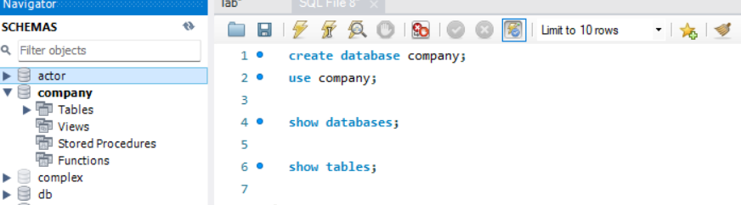use company;

Step 2: Display all databases,

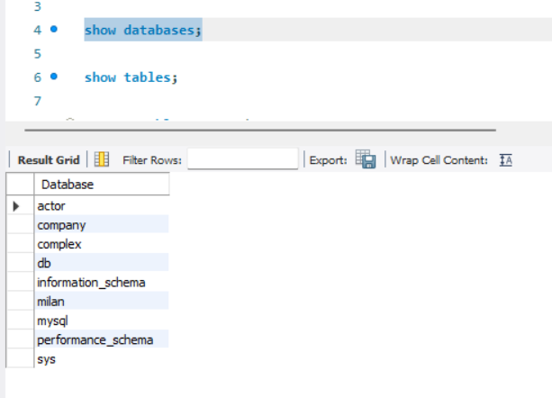show databases;

Step 3: Display all the tables.

show tables;

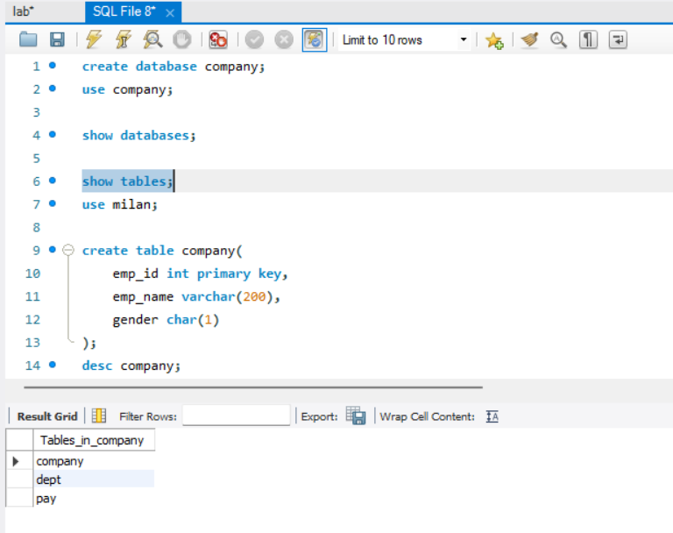

Step 4: Create the table.

create table company(

emp_id int primary key,

emp_name varchar(200),

gender char(1)

);

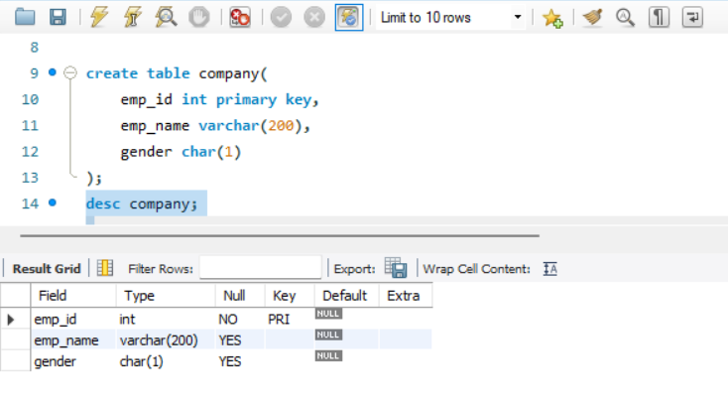desc company;

Step 5: Create the table with foreign key and primary key.

create table dept(

dept_id int primary key,

dept_name varchar(100)

);

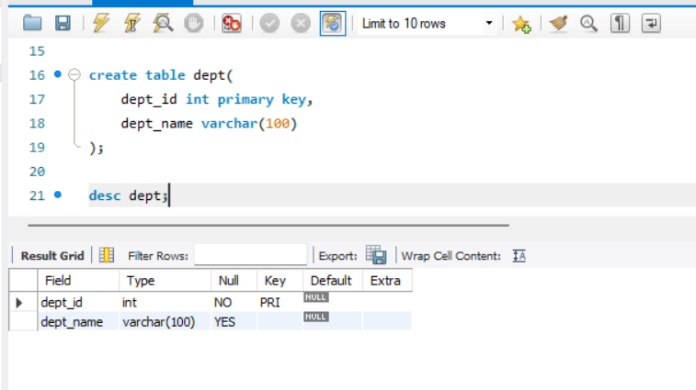desc dept;

Step 6: Create table with foreign key and primary key.

create table pay(

emp_id int,

dept_id int,

salary int,

primary key(emp_id,dept_id),

foreign key (emp_id) references company(emp_id),

foreign key (dept_id) references dept(dept_id)

);

desc pay;

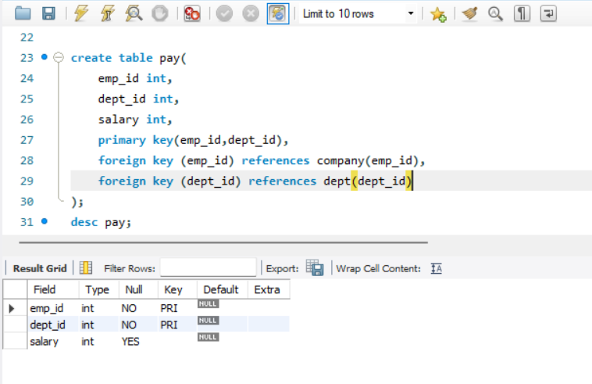

Step 6: Insert values into the tables.

-- inserting values into the company table

insert into company (emp_id,emp_name,gender) values (1,'John Doe','M');

insert into company (emp_id,emp_name,gender) values (2,'Jane Smith','F');

-- inserting values into the dept table

insert into dept(dept_id,dept_name) values (1,'HR');

insert into dept(dept_id,dept_name) values (2,'Finace');

-- inserting values into pay table

insert into pay(emp_id,dept_id,salary) values (1,1,5000);

insert into pay(emp_id,dept_id,salary) values (2,2,6000);

select * from company,dept,pay;

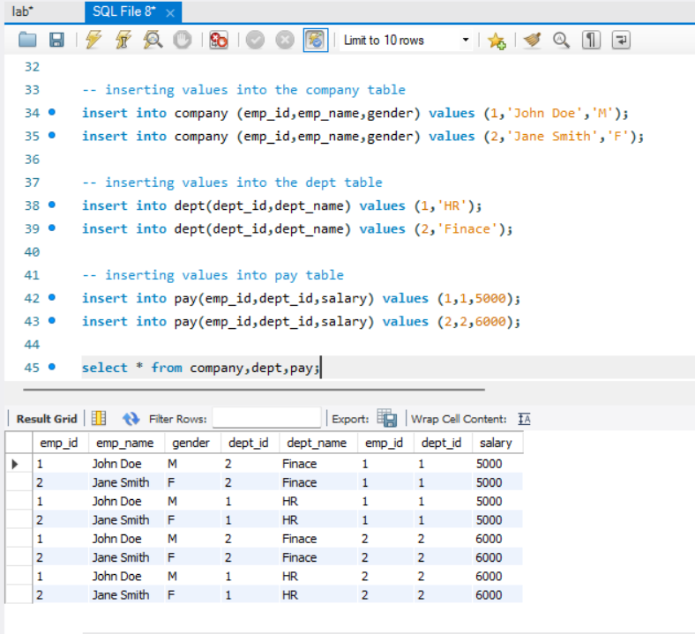

Step 7: Alter(update) the table and save permanently (commit).

update company set emp_name = 'Johna Hexa' where emp_id = 1;

commit;

select * from company;

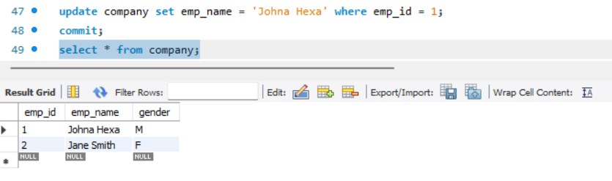

Step 8: Undo(rollback) the changes.

rollback;

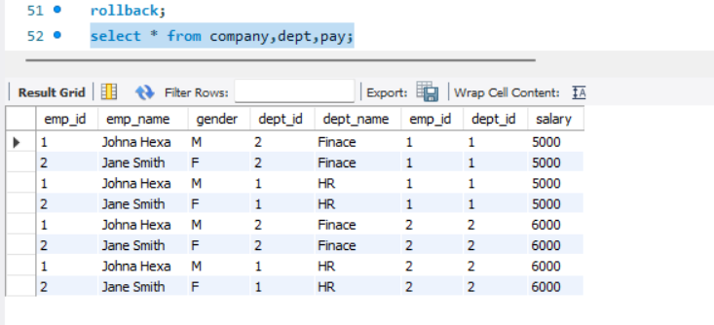select * from company,dept,pay;

*(No changes occur because COMMIT and ROLLBACK cannot be performed together)*

*(Lets try again for ROLLBACK)*

Step 9: Alter(update) the table and but don’t save permanently (commit).

update company set emp_name = 'Samantha Smith' where emp_id = 2;

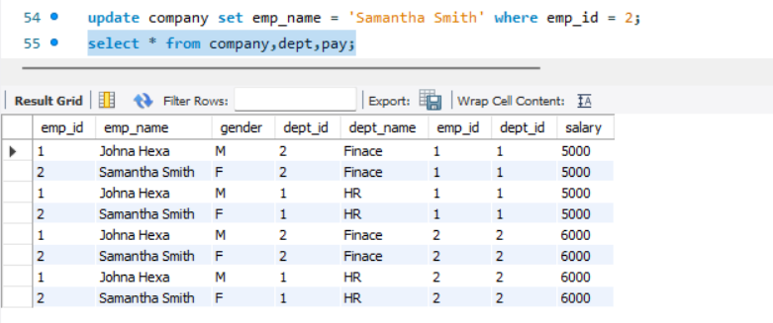select * from company,dept,pay;

Step 10: Now, rollback the changes.

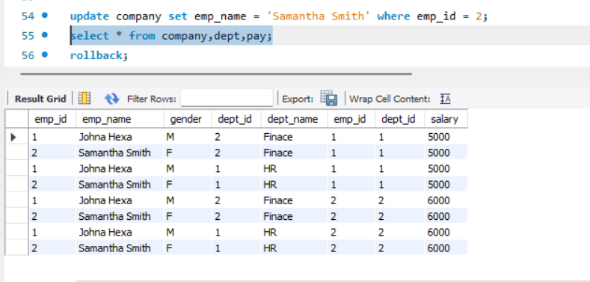rollback;

*(Rollback is executed)*

**4. Consider the following database with following Schema:**

* **Employee (fname,minit,lname,ssn,bdate,address,sex,salary,superssn,dno)**
* **Department (dname, dnumber, mgrssn, msrStartDate)**
* **Project (pname, pnumber, plocation, dnum) works_on (essn, pNo < hours)**
* **Dependent (essn, dependent_name, sex, bdate, relationship)**

**Perform the following:**

1. **Find the sum of the salaries of all employees of the ‘Accounts’ department, as well as the maximum salary, the minimum salary, and the average salary in the department.**
2. **For each project, retrieve the project number, the project name, and the number of employees who works on the project (use GROUP BY).**
3. **Retrieve the name of employees who are in the year 1990’s.**
4. **Retrieve the name of each employee controlled by a particular department.**
5. **Retrieve the name of each dept and number of employees working in each department.**
6. **Retrieve the department number and number of employees who are making a salary of more than 40000.**
7. **Retrieve the project number and the number of employees who work on that project.**

**SQL Command:**

Step 1: Create a table in database.

create table employee(

fname varchar(50), minit char(1),

lname varchar(50), ssn char(9) primary key,

bdate date, address varchar(100),

sex char(1), salary decimal(10,2),

superssn char(9) , dno int

);

desc employee;

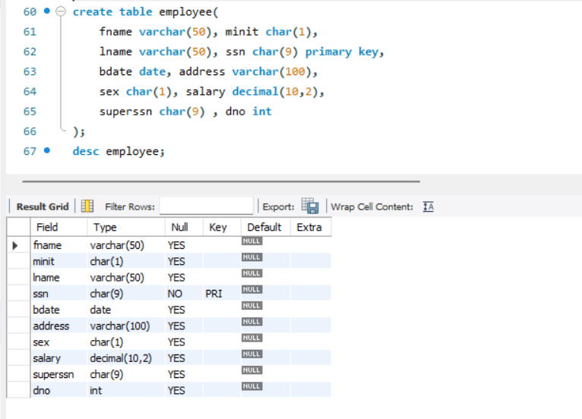

Step 2: Create the table in database.

create table department(

dname varchar(50),

dnumber int primary key,

mgrssn char(9),

msrStartDate date

);

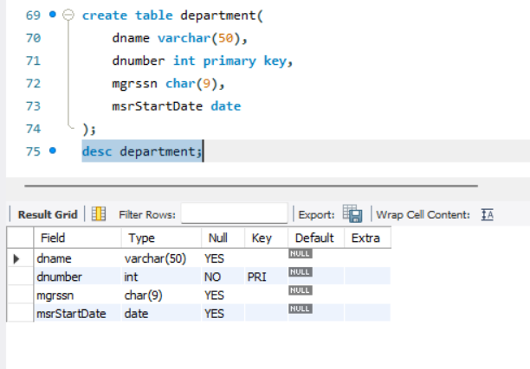desc department;

Step 3: Create a table in database.

create table dept_location(

dnumber int,

dlocation varchar(100),

primary key (dnumber, dlocation)

);

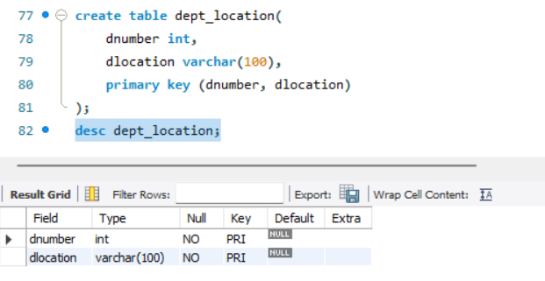desc dept_location;

Step 4: Create a table in database.

create table project (

pname varchar(50),

pnumber int primary key,

plocation varchar(100),

dnum int

);

desc project;

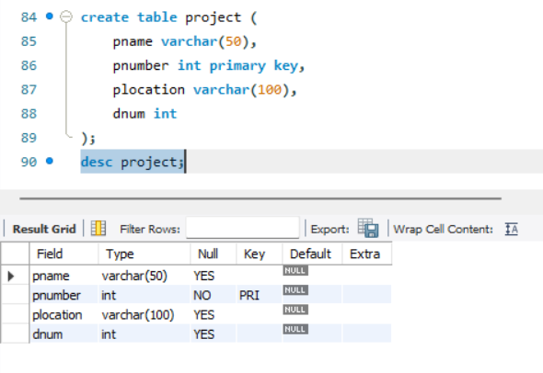

Step 5: Create a table in database.

create table works_on(

essn char(9),

pno int,

hours decimal(5,2),

primary key(essn,pno)

);

desc works_on;

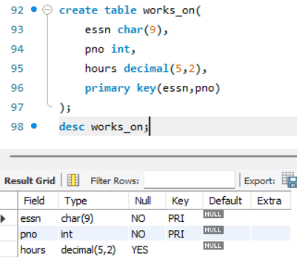

Step 6: Create a table in database.

create table dependent(

essn char(9),

dependent_name varchar(50),

sex char(1),

bdate date,

relationship varchar(20),

primary key(essn, dependent_name)

);

desc dependent;

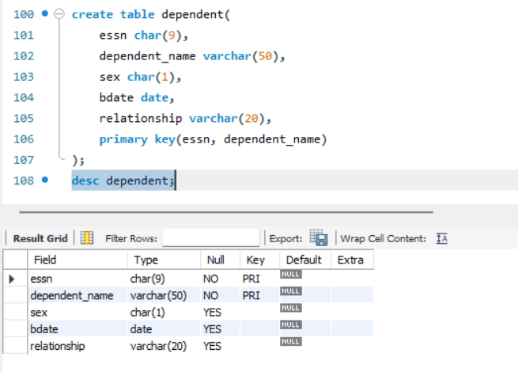

Step 7: Insert some values into those tables.

-- inserting values into employee

insert into employee values ('John','D','Doe','1234567','1990-05-01','123 Main St','M',50000,'98543222',1);

insert into employee values ('Jane','M','Smith','9834567','1985-08-15','456 Elm St','F',60000,'33443222',2);

insert into employee values ('David','S','Johnson','5544567','1992-12-10','789 Oak St','M',55000,'9876432',1);

insert into employee values ('Sarah','K','Brown','222333444','1991-03-25','321 Maple St','F',45000,'33325522',2);

insert into employee values ('Michael','R','Davies','44455556','1998-11-18','987 Fine St','M',70000,'5546733',3);

select * from employee;

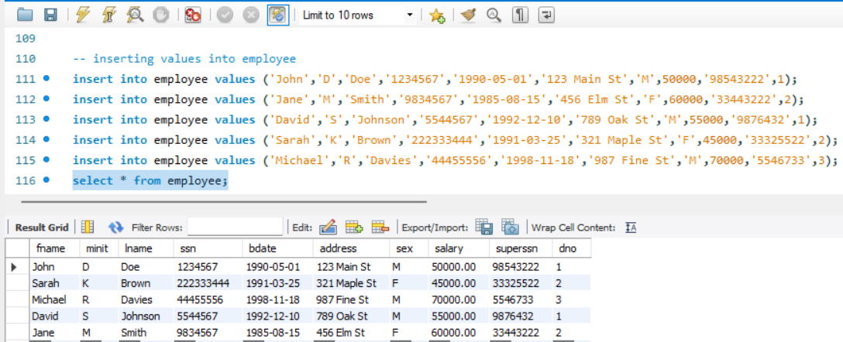

-- inserting values into department

insert into department values('Account',1,'987664321','2010-01-01');

insert into department values('Marketing',2,'33344555','2008-05-15');

insert into department values('IT',3,'987664321','2005-09-20');

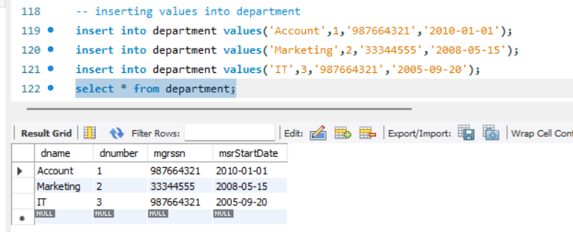select * from department;

-- inserting values into dept_location

insert into dept_location values(1,'Building A');

insert into dept_location values(2,'Building B');

insert into dept_location values(3,'Building C');

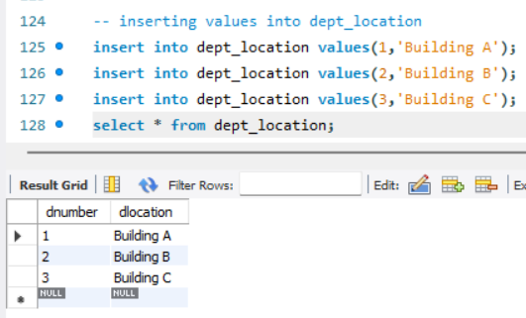select * from dept_location;

-- inserting values into project

insert into project values ('Project 1',1,'Location 1',1);

insert into project values ('Project 2',2,'Location 2',2);

insert into project values ('Project 3',3,'Location 3',3);

select * from project;

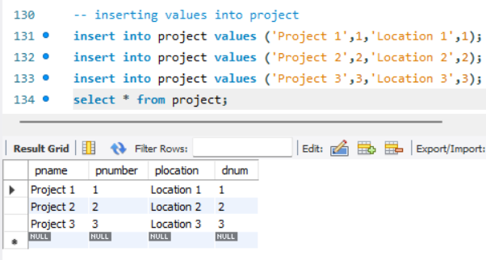

-

- inserting values into works_on

insert into works_on values('1234567',1,40);

insert into works_on values('22234423',1,35);

insert into works_on values('455334',2,30);

insert into works_on values('2222332',2,25);

insert into works_on values('5556667',3,20);

select * from works_on;

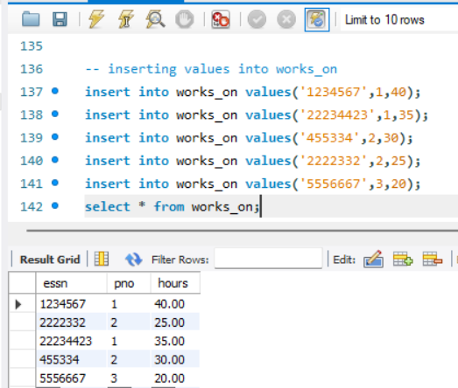

-- inserting into dependent table

insert into dependent values('1234567','Child 1','M','2010-02-14','Son');

insert into dependent values('22234423','Child 2','F','2012-06-25','Daughter');

insert into dependent values('455334','Child 1','M','2015-09-30','Son');

insert into dependent values('2222332','Child 1','F','2017-03-10','Daughter');

insert into dependent values('5556667','Child 1','M','2019-07-05','Son');

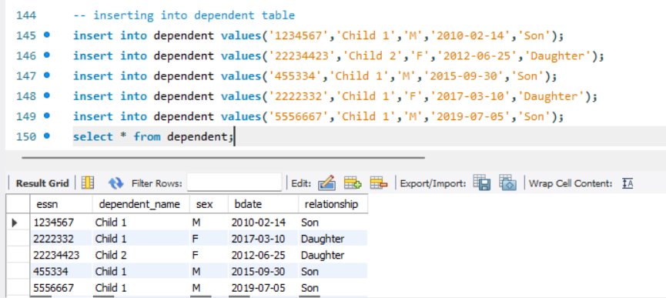select * from dependent;

Step 8: Solve the problems.

1. Find the sum of the salaries of all employees of the ‘Accounts’ department.

select

sum(salary) as total_salary,

max(salary) as max_salary,

min(salary) as min_salary,

avg(salary) as avg_salary

from

employee where dno = (select dnumber from department where dname = 'Account');

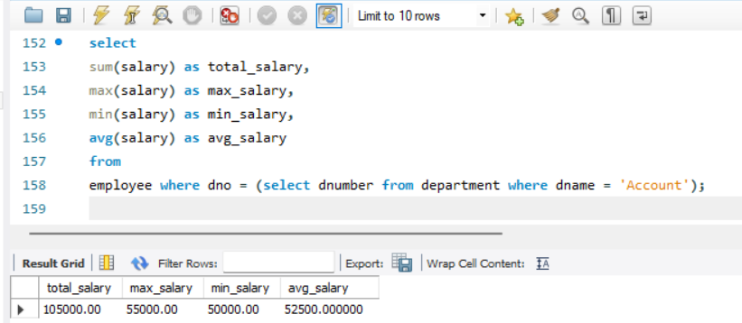

1. Retrieve the project number, project name, and the number of employees working on each project.

select pnumber,pname,

count(essn) as num_employees

from

project join works_on on project.pnumber = works_on.pno

group by

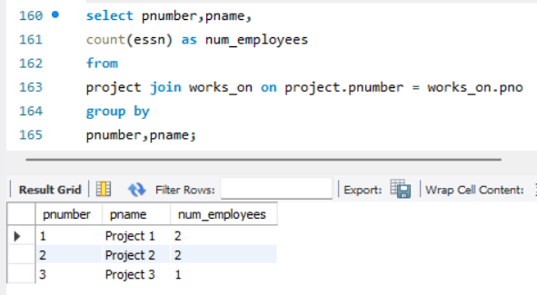pnumber,pname;

1. Retrieve the name of the employees born in the 1990s.

select fname,lname

from employee

where bdate between '1990-01-01' and '1999-12-31';

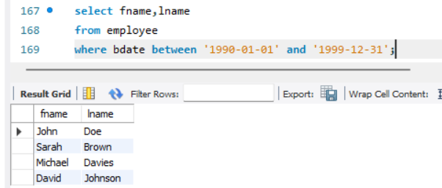

1. Retrieve the name of each employee controlled by a particular department.

select fname,lname

from employee

where ssn in (select mgrssn from department where dnumber = 1);

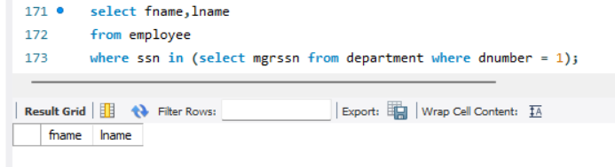

1. Retrieve the name of each dept and number of employees working in each department.

select d.dname, count(e.ssn) as num_employees

from

department d

left join employee e on d.dnumber = e.dno

group by

d.dname;

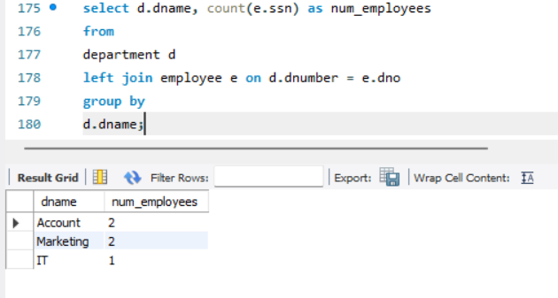

1. Retrieve the department number and number of employees who are making a salary of more than 40000.

select dno, count(*) as num_employees

from employee

where salary>40000

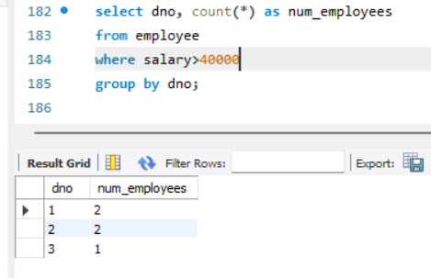group by dno;

1. Retrieve the project number and the number of employees who work on that project.

select pno as pnumber,count(*) as num_employees

from works_on

group by pno;

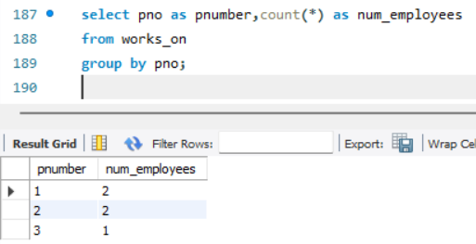

**5.Create a complex database and table with following attributes.**

* **Employee(emp_id,first_name,last_name,birth_day,sex,salary,super_id,branch_id)**
* **Branch(branch_id,branch_name,mgr_id,mgr_start_date)**
* **Client(client_id,client_name)**
* **Works_with(emp_id,client_id,total_sales)**
* **Branch_suppliers(branch_id,supplier_name,supply_type)**

**Perform the following:**

1. **Alter table employee with adding foreign key.**
2. **Insert data into the tables.**
3. **Show table of employee order by sex,first_name,last_name.**
4. **Find the first and last name of the employee.**
5. **Find the number of female employee born after 1970.**
6. **Find the first 5 employees in the table.**
7. **Find the forename and surnames of all employees.**
8. **Find the number of employee.**
9. **Find the average of all employees salaries.**
10. **Find out how many males and females are there.**
11. **Find the total sales of each salesman.**

**SQL Commands:**

Step 1: Create database Complex.

create database complex;

use complex;

Step 2: Create table in database.

create table employee(

emp_id int primary key,

first_name varchar(40),

last_name varchar(40),

birth_day date,

sex varchar(1),

salary int,

super_id int,

branch_id int

);

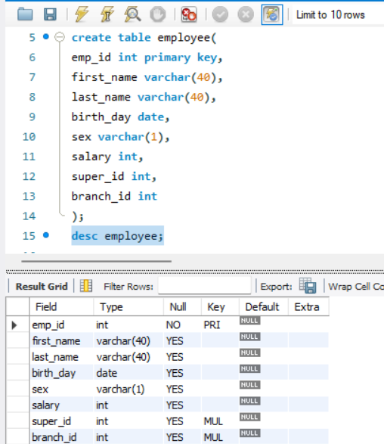desc employee;

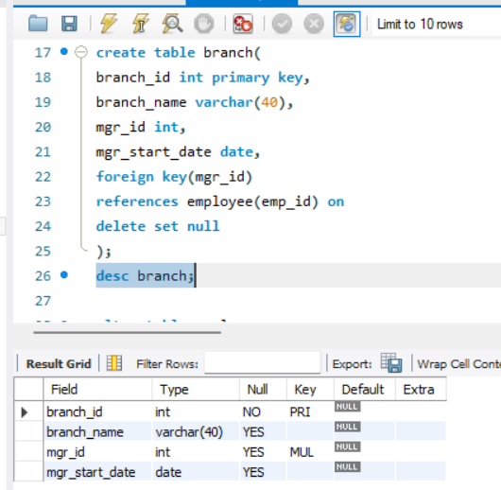

create table branch(

branch_id int primary key,

branch_name varchar(40),

mgr_id int,

mgr_start_date date,

foreign key(mgr_id)

references employee(emp_id) on

delete set null

);

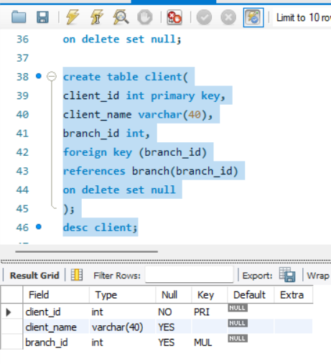create table client(

client_id int primary key,

client_name varchar(40),

branch_id int,

foreign key (branch_id)

references branch(branch_id)

on delete set null

);

desc client;

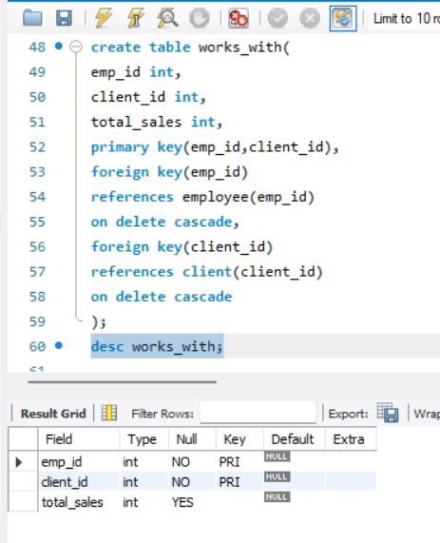

create table works_with(

emp_id int,

client_id int,

total_sales int,

primary key(emp_id,client_id),

foreign key(emp_id)

references employee(emp_id)

on delete cascade,

foreign key(client_id)

references client(client_id)

on delete cascade

);

desc works_with;

create table branch_suppliers(

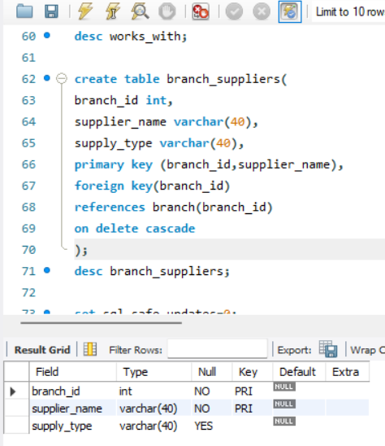branch_id int,

supplier_name varchar(40),

supply_type varchar(40),

primary key (branch_id,supplier_name),

foreign key(branch_id)

references branch(branch_id)

on delete cascade

);

desc branch_suppliers;

Step 3: Alter the table employee with foreign key.

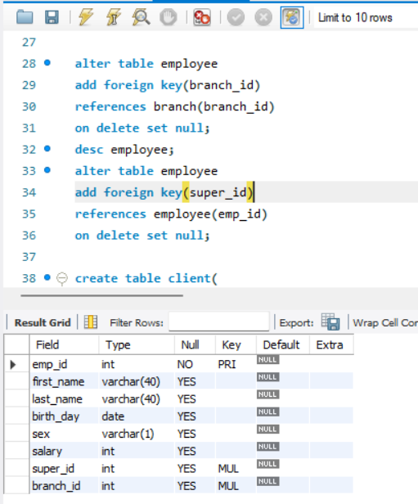alter table employee

add foreign key(branch_id)

references branch(branch_id)

on delete set null;

desc employee;

alter table employee

add foreign key(super_id)

references employee(emp_id)

on delete set null;

Step 4: Insert data into tables.

-- inserting into employee

insert into employee values(100,'David','Wallace','1967-11-17','M',250000,null,null);

INSERT INTO employee VALUES(101, 'Jan', 'Levinson', '1961-05-11', 'F', 110000, 100, 1);

INSERT INTO employee VALUES(102, 'Michael', 'Scott', '1964-03-15', 'M', 75000, 100, NULL);

INSERT INTO employee VALUES(103, 'Angela', 'Martin', '1971-06-25', 'F', 63000, 102, 2);

INSERT INTO employee VALUES(104, 'Kelly', 'Kapoor', '1980-02-05', 'F', 55000, 102, 2);

INSERT INTO employee VALUES(105, 'Stanley', 'Hudson', '1958-02-19', 'M', 69000, 102, 2);

INSERT INTO employee VALUES(106, 'Josh', 'Porter', '1969-09-05', 'M', 78000, 100, NULL);

INSERT INTO employee VALUES(107, 'Andy', 'Bernard', '1973-07-22', 'M', 65000, 106, 3);

INSERT INTO employee VALUES(108, 'Jim', 'Halpert', '1978-10-01', 'M', 71000, 106, 3);

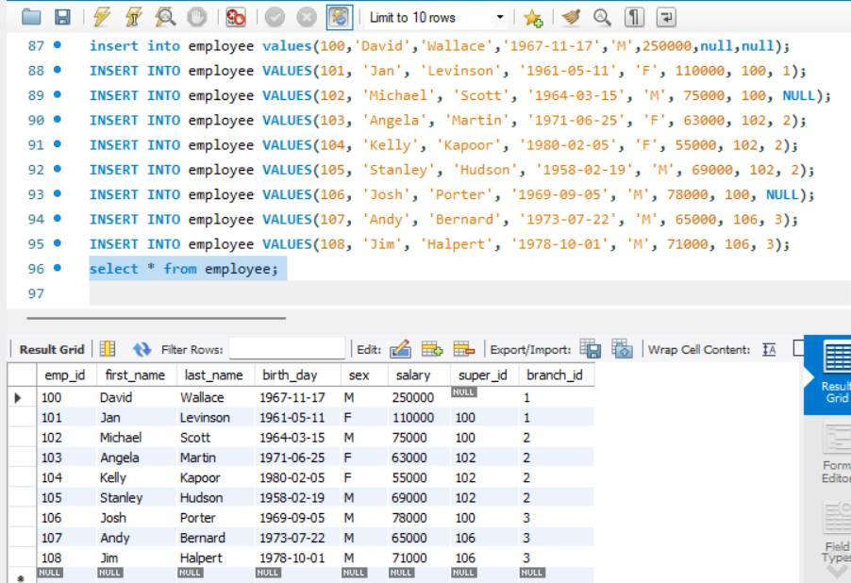

-- inserting into branch

insert into branch values(1,'Corporate',100,'2006-02-09');

INSERT INTO branch VALUES(2, 'Scranton', 102, '1992-04-06');

INSERT INTO branch VALUES(3, 'Stamford', 106, '1998-02-13');

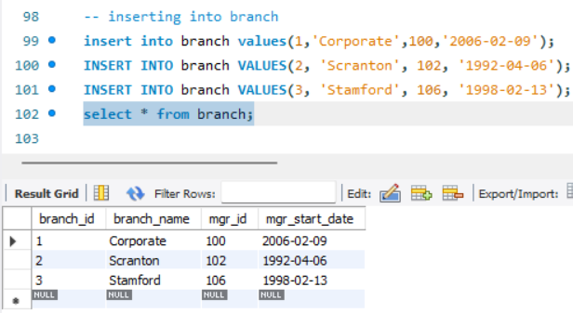

-- BRANCH SUPPLIER

INSERT INTO branch_suppliers VALUES(2, 'Hammer Mill', 'Paper');

INSERT INTO branch_suppliers VALUES(2, 'Uni-ball', 'Writing Utensils');

INSERT INTO branch_suppliers VALUES(3, 'Patriot Paper', 'Paper');

INSERT INTO branch_suppliers VALUES(2, 'J.T. Forms & Labels', 'Custom Forms');

INSERT INTO branch_suppliers VALUES(3, 'Uni-ball', 'Writing Utensils');

INSERT INTO branch_suppliers VALUES(3, 'Hammer Mill', 'Paper');

INSERT INTO branch_suppliers VALUES(3, 'Stamford Lables', 'Custom Forms');

select * from branch_suppliers;

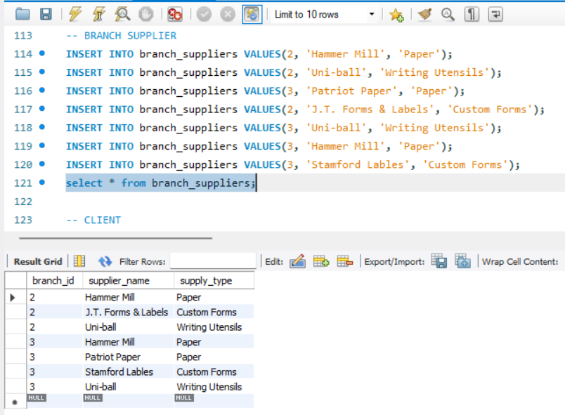

-- CLIENT

INSERT INTO client VALUES(400, 'Dunmore Highschool', 2);

INSERT INTO client VALUES(401, 'Lackawana Country', 2);

INSERT INTO client VALUES(402, 'FedEx', 3);

INSERT INTO client VALUES(403, 'John Daly Law, LLC', 3);

INSERT INTO client VALUES(404, 'Scranton Whitepages', 2);

INSERT INTO client VALUES(405, 'Times Newspaper', 3);

INSERT INTO client VALUES(406, 'FedEx', 2);

select * from client;

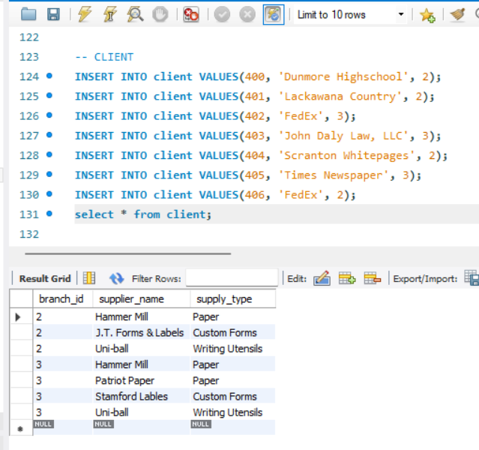

-- WORKS_WITH

INSERT INTO works_with VALUES(105, 400, 55000);

INSERT INTO works_with VALUES(102, 401, 267000);

INSERT INTO works_with VALUES(108, 402, 22500);

INSERT INTO works_with VALUES(107, 403, 5000);

INSERT INTO works_with VALUES(108, 403, 12000);

INSERT INTO works_with VALUES(105, 404, 33000);

INSERT INTO works_with VALUES(107, 405, 26000);

INSERT INTO works_with VALUES(102, 406, 15000);

INSERT INTO works_with VALUES(105, 406, 130000);

select * from works_with;

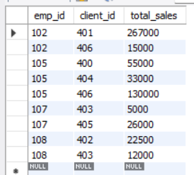

Step 5: Show employee table order by sex,first_name,last_name.

select * from employee

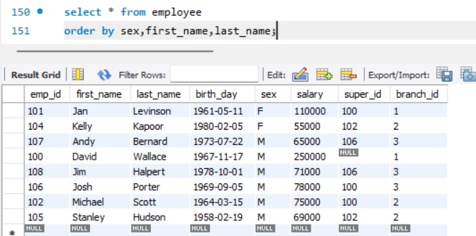order by sex,first_name,last_name;

Step 6: Find the first name and last names of all employee.

select first_name,last_name

from employee;

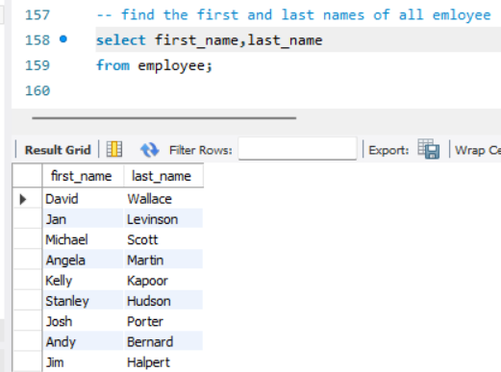

Step 7: Find the number of female employees born after 1970

select count(emp_id)

from employee

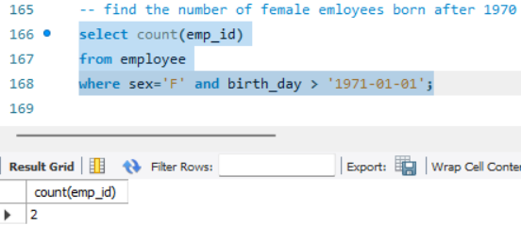where sex='F' and birth_day > '1971-01-01';

Step 8: Find the first 5 employees in the table.

select * from

employee

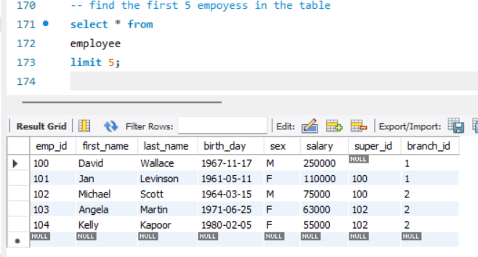limit 5;

Step 9: Find the forename and surnames of all employees.

select first_name as forename,last_name as surname

from employee;

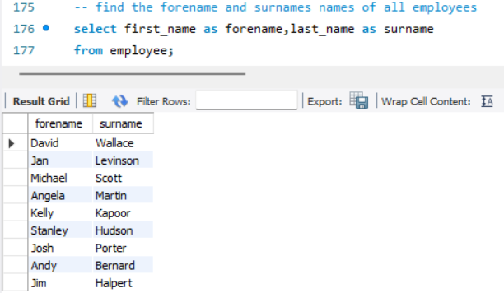

Step 10: Find the number of employee.

select count(emp_id)

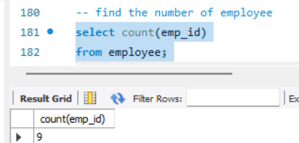from employee;

Step 11: Find the average of all employee salaries.

select avg(salary)

from employee

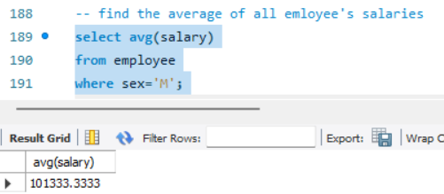where sex='M';

Step 12: Find out how many males and females are there.

select count(sex),sex

from employee

group by sex;

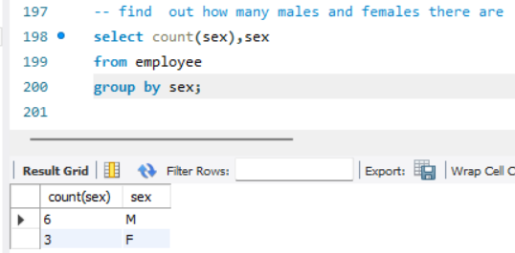

Step 13: Find the total sales of each salesman.

select sum(total_sales),client_id

from works_with

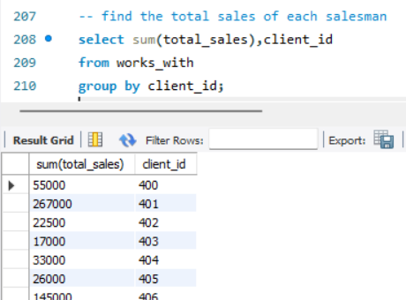group by client_id;

**6.From the above tables perform the following.**

1. **Find any client’s who are an LLC.**
2. **Find any employee born in October.**
3. **Find a list of employee and branch names.**
4. **Find all the list of all clients & branch suppliers names.**
5. **Find a list of all money spent or earned by the company.**
6. **Find the names of all employees who have sold over 30,000 to single client.**

**SQL Command:**

Step 1: Find any client’s who are an LLC.

select * from

client

where client_name like '%LLC';

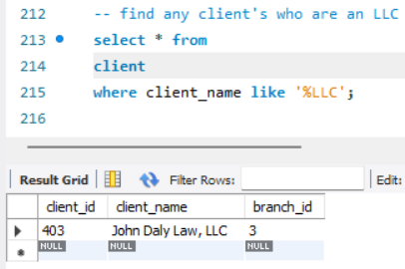

Step 2: Find any employee born in October.

select * from employee

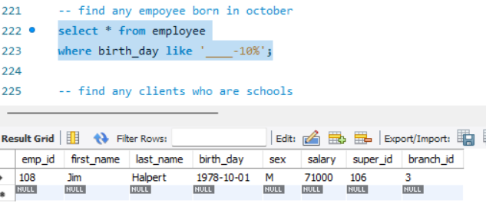where birth_day like '____-10%';

Step 3: Find a list of employee and branch names

select first_name

from employee

union

select branch_name

from branch

union

select client_name

from client;

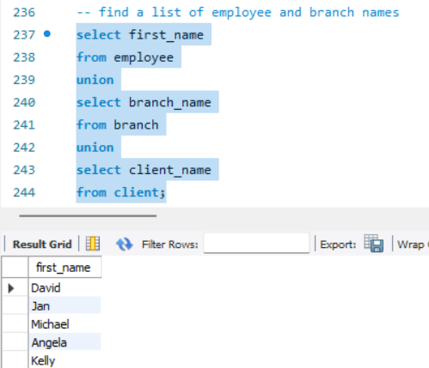

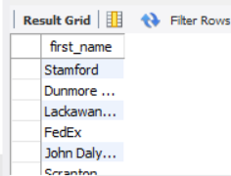

Step 4: Find all the list of all clients & branch suppliers names.

select client_name,client.branch_id

from client

union

select supplier_name,branch_suppliers.branch_id

from branch_suppliers;

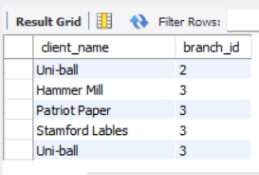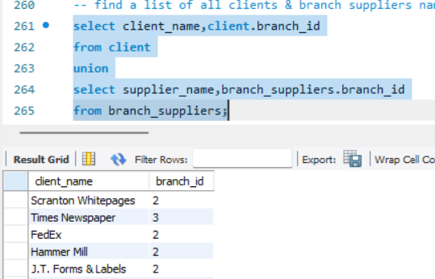

Step 5: Find a list of all money spent or earned by the company.

select salary

from employee

union

select total_sales

from works_with;

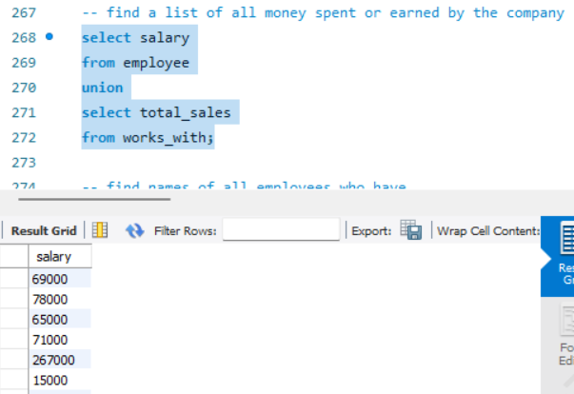

Step 6: find names of all employees who have sold over30,000 to a single client.

select employee.first_name,employee.last_name

from employee

where employee.emp_id in (

select works_with. emp_id

from works_with

where works_with. total_sales > 30000

);

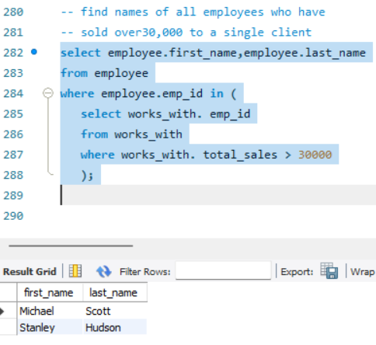

7.Create table products and perform the following.

1. Show product table.  
 -Creating database for product:

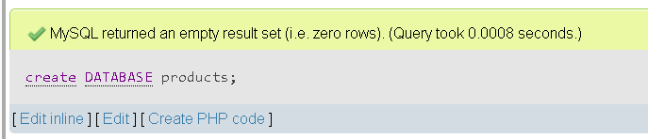

-Creating table named products:  
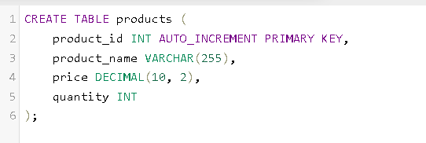

2. Create the log table to store insertion information.

-creating the log table:

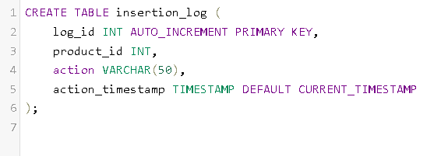

3. Create the INSERT trigger.

4. Create the UPDATE trigger

